Section 1: Case Summary

Scenario Title: | Cocaine-Induced Hypertensive Crisis
Keywords: | Sympathomimetic, Hypertension, Aortic Dissection
Brief Description of Case: | The patient is a 48 year old male presenting to the ED with chest pain and abdominal pain. Learner will need to ask about social history, specifically illicit drug use. Physical exam will be significant for tachycardia, unequal radial pulses, diastolic murmur and diffuse abdominal pain. Learner should recognize cocaine- induced hypertension complicated by aortic dissection and mesenteric ischemia. After CTA, the patient will develop cardiac tamponade from retrograde dissection requiring prompt pericardiocentesis.

Goals and Objectives
Educational Goal: | Manage cocaine-induced hypertension complicated by aortic dissection, mesenteric ischemic and cardiac tamponade
Objectives:  (Medical and CRM) | 1 – Recognize the importance of social history even in unstable patients  2 – Recognize patient is unstable and work-up cause  3 – Recognize and treat aortic dissection  4 – Stabilize patient prior to imaging  5 – Prompt disposition  6 – Troubleshoot shock in the patient with aortic dissection  7 – Perform pericardiocentesis
EPAs Assessed:

Learners, Setting and Personnel
Target Learners: | ☐ Junior Learners |  | ☒ Senior Learners |  |  | ☐ Staff
 | ☒ Physicians | ☐ Nurses |  | ☐ RTs | ☐ Inter-professional
 | ☐ Other Learners:
Location: | ☒ Sim Lab |  | ☐ In Situ |  |  | ☐ Other:
Recommended Number of Facilitators: | Instructors: 1
 | Sim Actors: 1
 | Sim Techs: 1

Scenario Development
Date of Development: | Nov 2019
Scenario Developer(s): | Suha Alshambari, MD, Shaza Aouthmany MD
Affiliations/Institutions(s): | University of Toledo Medical Center
Contact E-mail:
Last Revision Date: | Dec 2020
Revised By: | Chris Heyd, MD
Version Number:

Section 2A: Initial Patient Information

- Patient Chart
Patient Name: David Klutsky |  |  |  | Age: 49 | Gender: M | Weight: 80 kg
Presenting complaint: Abdominal pain
Temp: 37.8 | HR: 110 | BP: 191/105 |  | RR: 28 | O₂Sat: 95% | FiO₂: 21%
Cap glucose: 8.8 |  |  |  | GCS: 15
Triage note:
Mr. Klutsky developed sudden onset of chest and abdominal pain 2 hours ago. Transferred directly to resuscitation bed.

Allergies:
Past Medical History:  Hypertension  Polysubstance Abuse |  |  | Current Medications:  None

Section 2B: Extra Patient Information

A. Further History
Additional history from patient when asked directly

David Klutsky is a 49 year old man with history of HTN, alcohol and cocaine abuse.

Symptoms started 2 hours ago with abdominal pain that was sudden in onset, diffuse, crampy, 10/10 associated with one episode of bloody stool prior to presentation. This then travelled up into his chest.

Patient was actively using cocaine when the pain started. He has been smoking cocaine nearly every day for the past 5 years. He was prescribed antihypertensives 3 years ago but does not take them.

B. Physical Exam
List any pertinent positive and negative findings
Cardio: Diastolic murmur over aortic valve, unequal BP and pulses | Neuro: Normal
Resp: Tachypnea, otherwise normal | Head & Neck: Pupils 5mm
Abdo: Diffuse tenderness without guarding | MSK/skin: Diaphoretic
Other: Appears anxious and unwell

Section 3: Technical Requirements/Room Vision

A. Patient
☒ Mannequin: Adult
☐ Standardized Patient
☒ Task Trainer: Pericardiocentesis (optional)
☐ Hybrid
B. Special Equipment Required
Critical care equipment
Pericardiocentesis kit (optional)

C. Required Medications
Critical care medications

D. Moulage
Diaphoresis

E. Monitors at Case Onset
☐ Patient on monitor with vitals displayed
☒ Patient not yet on monitor
F. Patient Reactions and Exam
Include any relevant physical exam findings that require mannequin programming or cues from patient
(e.g. – abnormal breath sounds, moaning when RUQ palpated, etc.) May be helpful to frame in ABCDE format.

Anxious, distressed, in severe pain
Diffuse severe abdominal pain to palpation
BP: Right 191/110, Left 120/60
Radial Pulse: Right Normal, Left decreased

Section 4: Sim Actors and Standardized Patients

Sim Actor and Standardized Patient Roles and Scripts
Role | Description of role, expected behavior, and key moments to intervene/prompt learners. Include any script required (including conveying patient information if patient is unable)
Bedside RN | Assist with starting IV, drawing labs and giving medications and updating with changes in vitals and preventing patient harm. Helpful and skilled.

Section 5: Scenario Progression

Scenario States, Modifiers and Triggers
Patient State/Vitals | Patient Status | Learner Actions, Modifiers & Triggers to Move to Next State |  | Facilitator Notes
1. Initial Assessment  Rhythm: sinus tach  HR: 110  BP: 191/100  RR: 28  O₂SAT: 95%  T: 37.8ºC  GCS: 15 | Patient distressed and moaning throughout.  Able to give reliable history | Expected Learner Actions  Monitors, IV, vitals, CBG  Focused history and physical  Bloodwork, EKG  Chest X-ray  Recognize clinical signs of aortic dissection | Modifiers  - Attempt to send to CT without starting meds → RN to intervene  Triggers  For progression to next state  -All actions complete → Stage 2
2. Stabilization  Same as state 1 |  | Expected Learner Actions  IV benzodiazepine  IV opioid  IV beta blocker  Arrange stat CTA  Call cardiothoracic surgery | Modifiers  - Benzo/opioid → HR80 BP150/80  - BB → HR 60 BP 100/60  Triggers  - Medications given → Stage 3
3. Return from CT/Tamponade  Rhythm: sinus tach  HR: 130  BP: 63/40  O₂SAT: 92%  GCS: 8 (E2V2M4) | Decreased level of consciousness.  Only moaning | Expected Learner Actions  Reassess patient  Stop IV infusions  Bedside ultrasound  Prepare for pericardiocentesis | Modifiers  - Stop IV meds → BP 80/45  Triggers  - Ready for pericardiocentesis → Stage 4 | **Give CT report at beginning of state**
4. Resolution  Same as state 3 |  | Expected Learner Actions  Consider sedation  Perform pericardiocentesis  Prepare for RSI | Modifiers  -  Triggers  - Pericardiocentesis → End of case | May use pericardiocentesis trainer or have learner “talk through procedure”

Appendix A: Laboratory Results

None given in this case

Appendix B: ECGs, X-rays, Ultrasounds and Pictures

Paste in any auxiliary files required for running the session. Don’t forget to include their source so you can find them later!

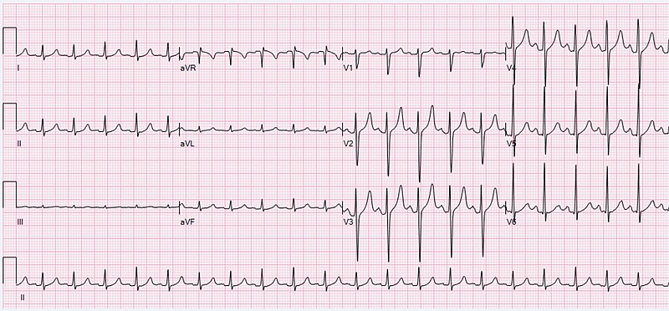
From Wikipedia (https://commons.wikimedia.org/wiki/File:ECG_Sinus_Tachycardia_125_bpm.jpg)

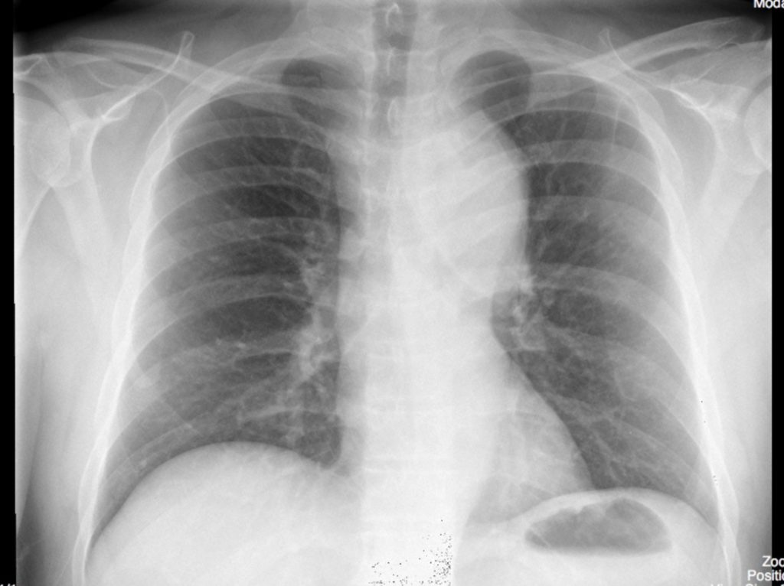
From Medical Imaging Solutions for Teaching and Research, University of Saskatchewan (https://mistr.usask.ca/odin/?caseID=20170414181501895)

CT Report

TECHNIQUE: Contrast-enhanced arterial phase images of the chest, abdomen,
and pelvis with coronal, sagittal, and 3-D reformats.

ANGIOGRAPHIC FINDINGS

There is Type A aortic dissection arising from the proximal ascending thoracic aorta at the level of the aortic root and involving the aortic valve. The dissection flap continues throughout the aortic arch and descending thoracic aorta as well as the suprarenal and infrarenal abdominal aorta extending into the right common iliac artery and proximal right external iliac artery.

Standard arch branching pattern with the dissection extending along the brachiocephalic artery, both visualized common carotid arteries as well as the proximal left subclavian artery. False lumen involves the SMA leading to reduced opacification and mesenteric ischemia. No dissection of the celiac trunk, IMA or bilateral main renal arteries.

The true lumen supplies the arch vessels, celiac trunk, IMA and left main renal artery with both the true and false lumen supplying the right main renal artery.

SUMMARY

Type A aortic dissection from the aortic root (including aortic valve) to the right iliac artery. SMA is occluded leading to mesenteric ischemia.

Appendix C: Facilitator Cheat Sheet & Debriefing Tips

Include key errors to watch for and common challenges with the case. List issues expected to be part of the debriefing discussion. Supplemental information regarding any relevant pathophysiology, guidelines, or management information that may be reviewed during debriefing should be provided for facilitators to have as a reference.

Key errors:

1 – Insufficient consideration of aortic dissection/insufficient assessment
2 – Sending patient to the CT scanner prior to stabilization
3 – Delayed consultation to cardiothoracic surgery

Debriefing Topics:

1 – Talk about cocaine induced hypertension and treatment
2 – Pathophysiology of aortic dissection
3 – Complications of aortic dissection – mesenteric ischemia, stroke, myocardial ischemia, limb ischemia, as well as pericardial tamponade
4 – Prompt disposition, highlighting learner’s institutional pathway
5 – Treatment before CTA completed, pearls and pitfalls

References

1. Cardiovascular effects of Cocaine. 2017. Journal of the American College Of Cardiology http://dx.doi.org/10.1016/j.jacc.2017.05.014
2. Guidelines for the Diagnosis and Management of Patients With Thoracic Aortic Disease. 2010. Circulation https://doi.org/10.1161/CIR.0b013e3181d4739e
3. EMCRIT https://emcrit.org/toxhound/cocaine-beta-blockers-dogmalysis-wont-hunt/
4. Rosen's Emergency Medicine (9th Edition)

